1. Write a c program for linked list.

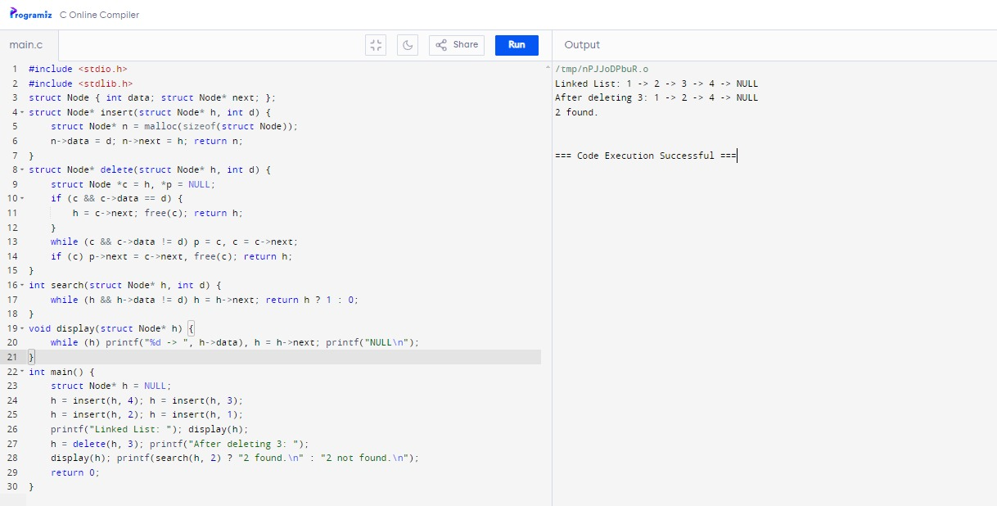

1. Write a c program for single linked list.



1. Write a c program for double linked list.

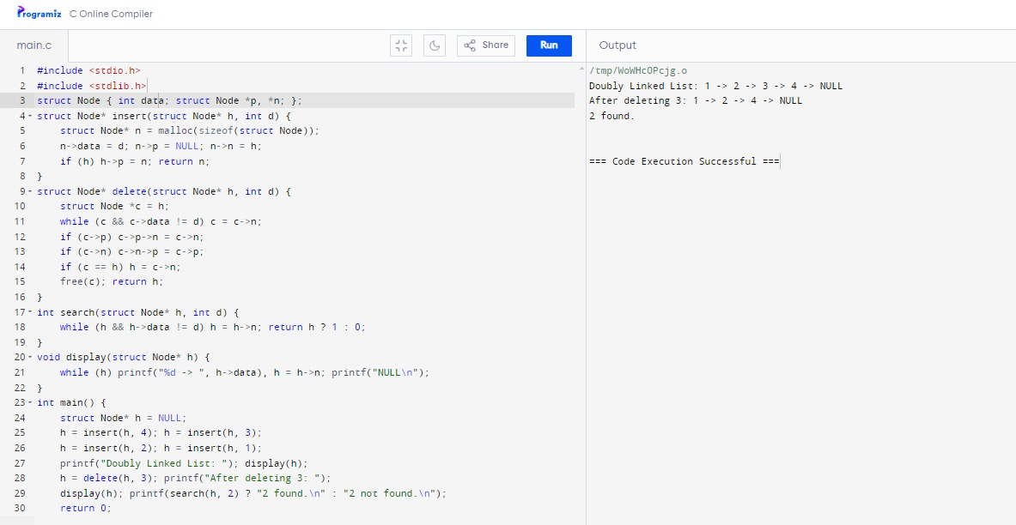

1. Write a c program circular linked list.

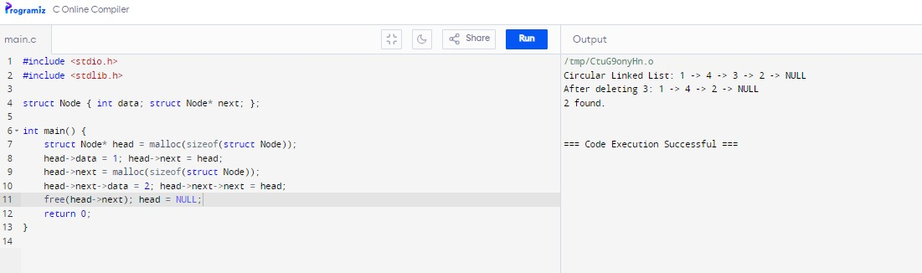

1. Write a c program stack using all operations push, pop, peek, full, empty.

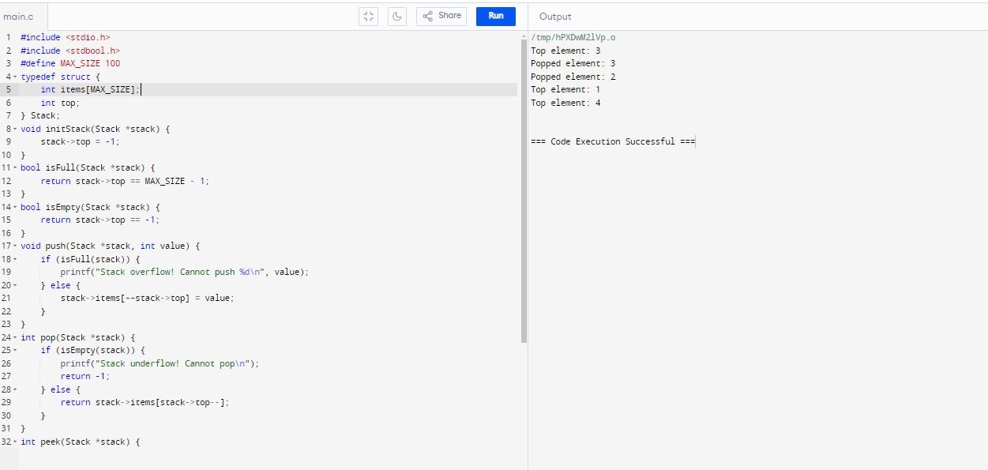

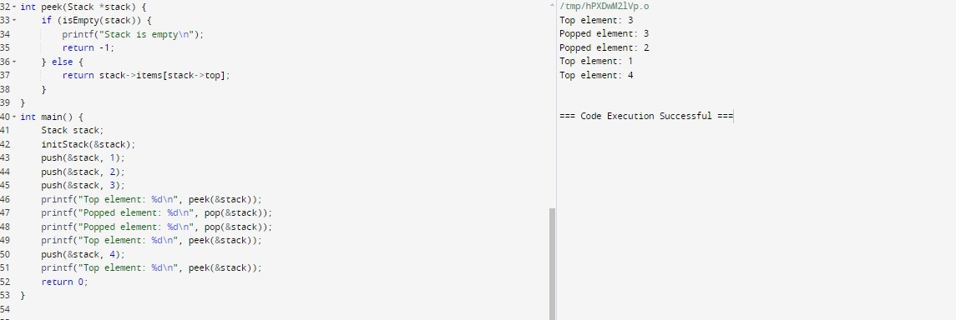

1. Write a c program for array implementation of stack.

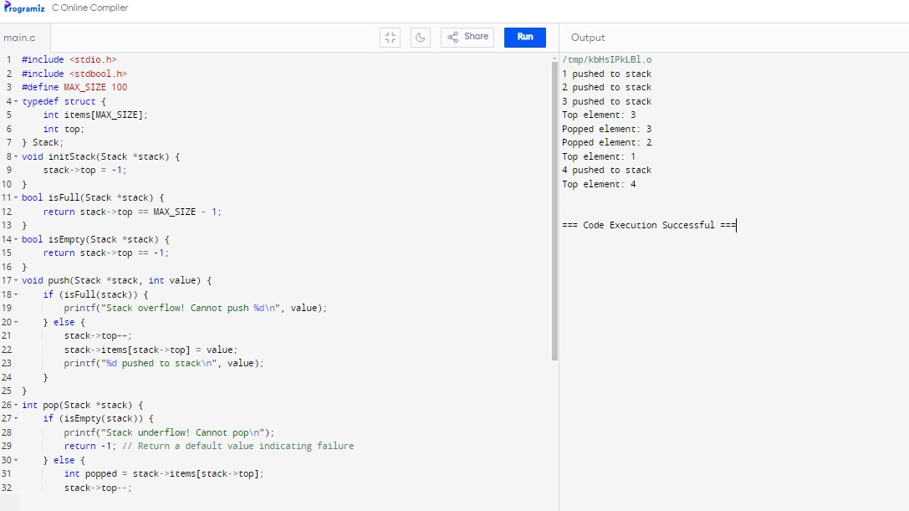

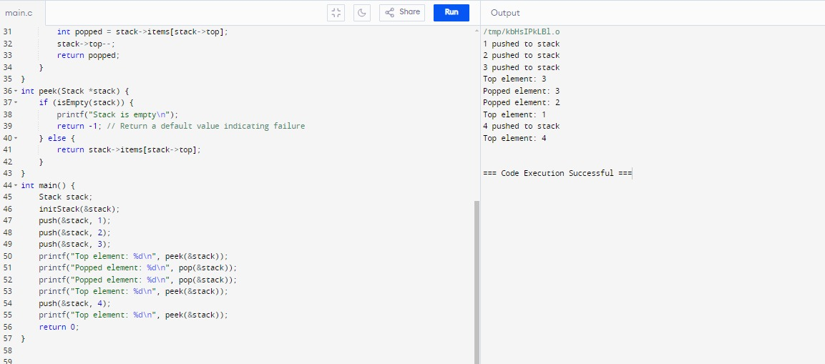

1. Write a c program that implements a stack using linked list.



